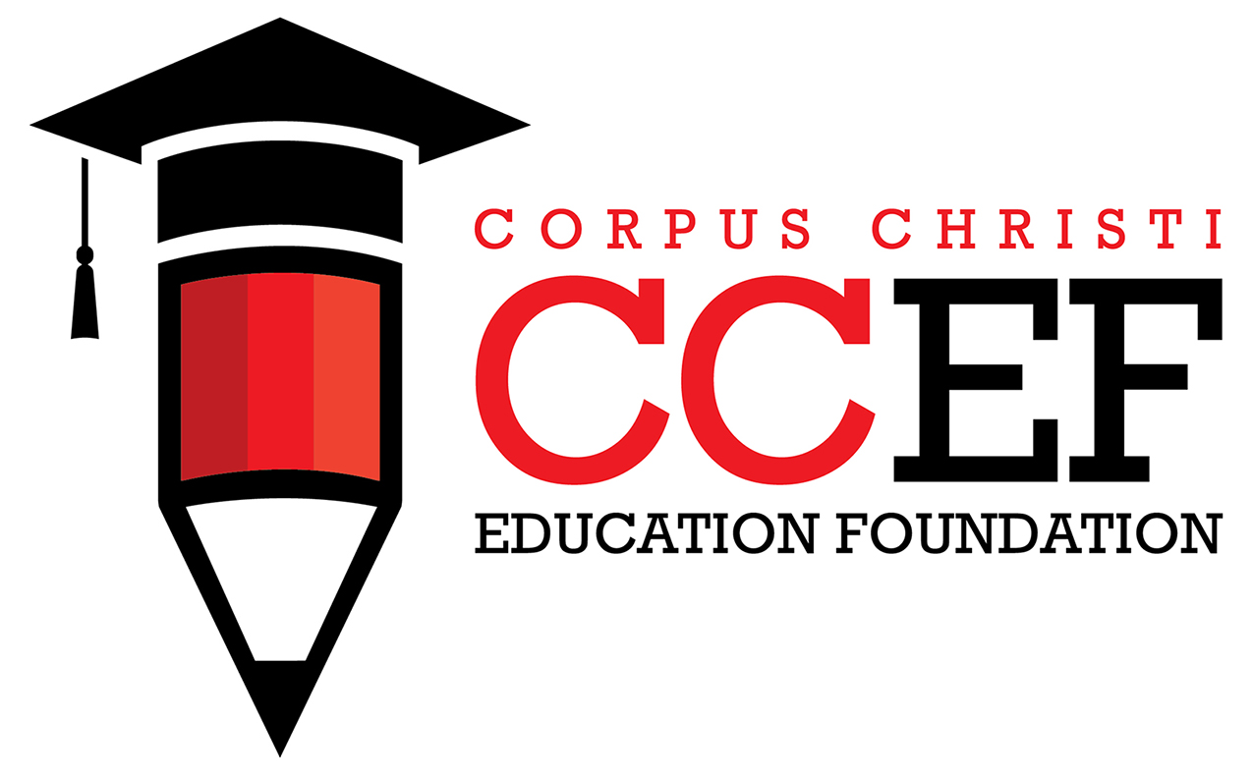
Bill & Mary Hamrick Scholarship - 2025
DEADLINE: Wednesday, March 5, 2025

Scholarship Eligibility – Applicant must be a current, graduating senior from W.B. Ray High School who will enroll in college in the fall immediately following graduation, with proven academic achievement and a commitment to excellence in athletics. Selected recipient(s) will be awarded a $250 scholarship. Scholarship recipient(s) must enroll in and maintain a minimum of 12 semester hours in Fall 2025.

Applicant Contact Information – Type or print in black or blue ink.

Name: ___________________________________________________________________________________________________
Last Name First Name Middle Initial
Permanent Address: ______________________________________________________________________________
Street Apt#
______________________________________________________________________ Home phone: ___________________
City State Zip Code

Cell-phone: ____________________________ Date of Birth: _____/______/______
High School: ___________________________ Student ID#: __________________

I certify the information provided in this application is, to the best of my knowledge, true and correct. I understand this application is subject to verification by the Coastal Bend Community Foundation and the Corpus Christi Education Foundation at its discretion.
My signature serves as permission for the Coastal Bend Community Foundation and the Corpus Christi Education Foundation to publish my name and photos in the event I receive a scholarship.
Signature of Applicant: _____________________________________________ Date: ___________
Student’s Email *: _____________________________________________________________________

IF APPLICANT IS UNDER 18, THE SIGNATURE OF A PARENT OR GUARDIAN IS REQUIRED:

I certify the information provided in this application is, to the best of my knowledge, true and correct. I understand this application is subject to verification by the Coastal Bend Community Foundation and the Corpus Christi Education Foundation at its discretion.
My signature serves as permission for the Coastal Bend Community Foundation and the Corpus Christi Education Foundation to publish my child’s name and photos in the event he/she receives a scholarship.

Parent/Guardian Signature: ___________________________________________ Date: __________
Parent’s/Guardian’s Email*: _______________________________________________________________
*Email addresses will be used to communicate with you regarding your application and to keep you informed of other opportunities from the Corpus Christi Education Foundation. Your contact information will NOT be provided to any other organization, and will NOT be added to any third party mailing lists
High School Scholastic Achievement:
To ensure eligibility for this scholarship award, you MUST include the following:
- Attach a copy of your most recent high school transcript, with GPA and course grades clearly visible, to this application (note: GPA is usually listed at the bottom of the page – be sure it’s not cut off in a copy submitted).

To ensure highest score possible, also include the following:
  - Attach a copy of your SAT score(s).
  - Attach a copy of your ACT score(s).
Most students submit a copy of the printed results sheet with total score visible. Identifying information must also be visible to verify that the score(s) are your own.

Involvement in Athletics: List school-related athletics programs in which you have participated during high school and CHECK THE BOX for each school year you participated. Please do not attach additional information; if you have more than what is listed here, choose the top six activities on your list.

Athletics Program(s) Freshman Sophomore Junior Senior
 | □ | □ | □ | □
 | □ | □ | □ | □
 | □ | □ | □ | □
 | □ | □ | □ | □
 | □ | □ | □ | □
 | □ | □ | □ | □

Awards and Honors: List awards and honors which you received related to excellence in high school athletics, and CHECK THE BOX for the school year that you received the honor. Please do not attach additional information.

Honors/Awards in Athletics Freshman Sophomore Junior Senior
 | □ | □ | □ | □
 | □ | □ | □ | □
 | □ | □ | □ | □
 | □ | □ | □ | □
 | □ | □ | □ | □
 | □ | □ | □ | □

Personal Statement: Please attach a typed one-page essay between 250 and 400 words describing how involvement in athletics and focusing on academic achievement has made a difference in preparing you for future success. Please include your Student ID number on the separate sheet – do not include your name or any other identifying information on your typed essay.

College Plans: What college/university or trade school do you hope to attend in the Fall of 2025?

1st Choice: Date of Acceptance: _ Name of College/University
________________________________________________________________ ________________
Mailing Address of Financial Aid Office

2nd Choice: Date of Acceptance: _________ Name of College/University
__________________________________________________________________ ____ _____________
Mailing Address of Financial Aid Office

Major or intended major(s):
Intended career:

Application Checklist & Attachments - **Please do not use staples**

IMPORTANT: Did you remember to …?
- Complete and sign this three-page application form?
- Include a copy of the required transcript, which includes GPA, class rank?
- Include a copy of SAT and/or ACT scores?
- Include your typed personal statement essay?

Email completed applications and supporting documentation to Eloisa.Dowiat@ccisd.us.

Submit or postmark by the deadline: Wednesday, March 5, 2025
Late applications will not be considered.

